Read the *entire* instructions before you try to follow them. Knowing where you are going will help.

It helps to have the Formatting Reference and the Style Reference documentation as you move through this workflow.

First, **Show Hidden Characters** (ctrl+alt+i) and the **Highlight Override** feature ([a] at the top of the Paragraph Style menu). Don’t do anything before turning these on.

# Initial Formatting

**Introductions**, like all apparatus, do not require semantic tagging but will require the application of **Paragraph** and **Character Styles** that apply the necessary formatting. All formatting *must* be done through these **Styles**, otherwise overrides will occur and / or the formatting will not appear in the export – in both instances, this will prevent the text from being formatted properly both in print and online.

Format each paragraph individually, making sure each is correct before moving on to the next paragraph. Also check headings at the same time. Move through the **Introduction**, methodically correcting the formatting by applying **Paragraph** and **Character Styles**.

This is what a typical **Introduction** looks like once you have imported it and turned on the **highlight override** and **show hidden symbols**. The text is completely overridden, but it keeps a lot of the initial formatting, such as italics and tabs.

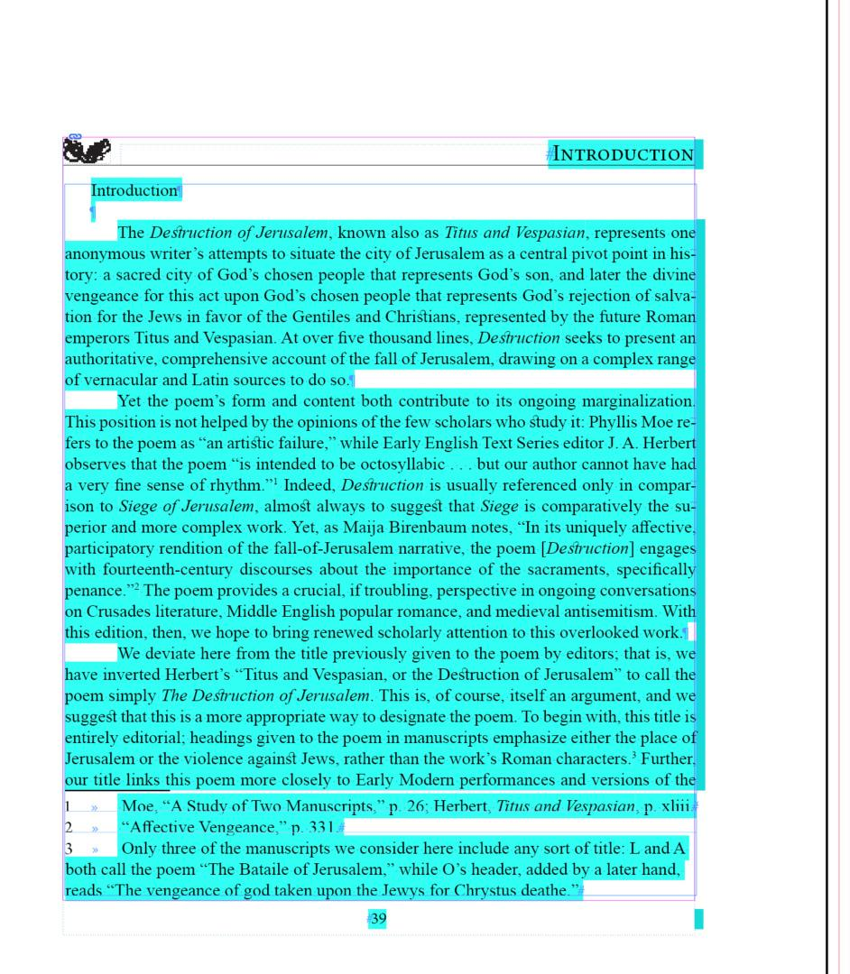

Delete the title of the text (“Introduction”) and the two **end of paragraph** symbols that follow the title so that the text begins at the top of the textbox (the blue line). As you format, remember: Use the formatting that’s been imported!

## Adding Queries in Asana

If something seems incorrect, start a query list in Asana. You’ll want to document queries in the Print Production section of your Editor-Volume’s Asana Project; each query should be its own subtask attached to the task “Introduction,” nested under the task “InDesign Formatting.”

* Review the Queries in Asana workflow for details on how we structure queries.

# Formatting Paragraphs

## Format the first paragraph of text.

* Refer to the section Character Styles – Formatting Only in the Style Reference for the full list of **Character Styles** to use for formatting. If, for instance, the phrase is italic, highlight the entire phrase and then apply the **Italic** Character Style.
* Language tags, only **Arabic** and **Hebrew**, in order to remove overrides (see Style Reference, section Character Styles – Languages, as needed)
* Check **em-dashes** (between clauses) and **en-dashes** (between number ranges) for correctness (see Formatting Reference, sections Em-dash and En-dash, for full instructions)
* Middle English characters (see Formatting Reference, section Middle English Characters)
* Ellipses (see Formatting Reference, section Ellipses)
* Backslash between lines: if there are quoted verse lines within a paragraph separated by a backslash [/], make sure there is a space on either side of the backslash

Apply a **Paragraph Style** to the first paragraph of text

* Click into the paragraph and tag it as **Body First** (See Style Reference as needed)
* Clear any overrides. Refer to Formatting Reference (section Overrides) as needed.
* Check against the original text in case all formatting did not import.

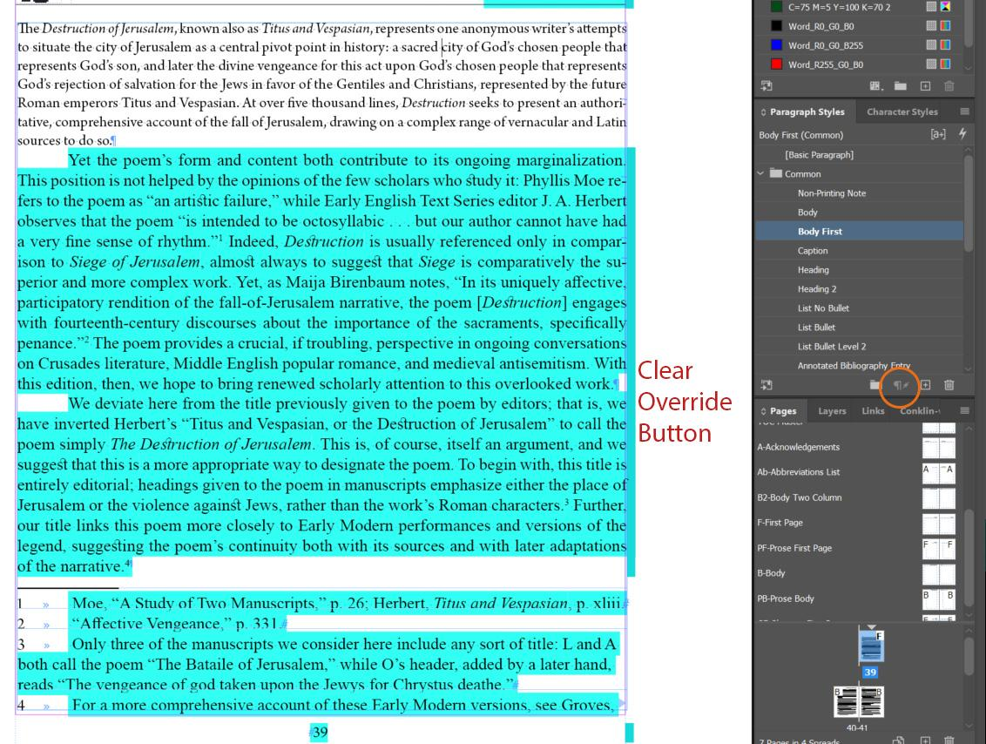

## Format the second paragraph of text.

As with the first, use the formatting that’s been imported:

* Refer to the section Character Styles – Formatting Only in the Style Reference for the full list of **Character Styles** to use for formatting. If, for instance, the phrase is italic, highlight the entire phrase and then apply the **Italic** Character Style.
* Language tags, only **Arabic** and **Hebrew**, in order to remove overrides (see Style Reference, section Character Styles – Languages, as needed)
* Check **em-dashes** (between clauses) and **en-dashes** (between number ranges) for correctness (see Formatting Reference, sections Em-dash and En-dash, for full instructions)
* Middle English characters (see Formatting Reference, section Middle English Characters)
* Ellipses (see Formatting Reference, section Ellipses)
* Backslash between lines: if there are quoted verse lines within a paragraph separated by a backslash [/], make sure there is a space on either side of the backslash

Apply the **Paragraph Style**:

* Click into the paragraph and tag it as **Body**. (See Style Reference as needed)
  + In the example below, note that there is no tab symbol at the start of the second paragraph, where we have applied the **Body** paragraph style. This is correct, as the indent is built into the paragraph style.
* Clear any overrides. Refer to Formatting Reference (section Overrides) as needed.
* Check against the original text in case all formatting did not import.

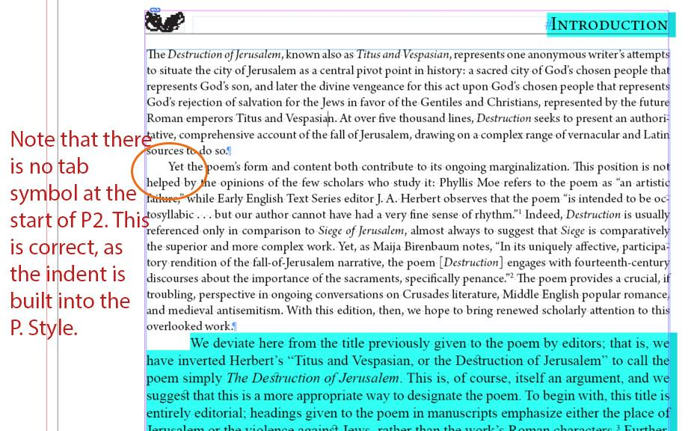

Continue formatting each paragraph until you reach a new type of **Paragraph Style**, such as a block quote, heading, list, etc. and then skip to the relevant section in these instructions. Note that you *do not* add extra **end of paragraph** symbols between any of these paragraphs (or ever!).

# Formatting Footnotes

This can happen at any time. It’s up to you if you want to format all the text first or if you want to pause at the bottom of each page to format the footnotes.

As with formatting paragraphs, you will want to use the formatting that is present before you clear the override.

* Refer to the section Character Styles – Formatting Only in the Style Reference for the full list of **Character Styles** to use for formatting. If, for instance, the phrase is italic, highlight the entire phrase and then apply the **Italic** Character Style.
* Language tags, only **Arabic** and **Hebrew**, in order to remove overrides (see Style Reference, section Character Styles – Languages, as needed)
* Check **em-dashes** (between clauses) and **en-dashes** (between number ranges) for correctness (see Formatting Reference, sections Em-dash and En-dash, for full instructions)
* Middle English characters (see Formatting Reference, section Middle English Characters)
* Ellipses (see Formatting Reference, section Ellipses)
* Backslash between lines: if there are quoted verse lines within a paragraph separated by a backslash [/], make sure there is a space on either side of the backslash

Apply the **Footnote** Paragraph Style

* Double check here that you have edited the Document Footnote Options menu to apply styles to footnote reference numbers and the footnotes themselves globally throughout the document. This also edits the spacing between the text and the footnotes.
  + For more instructions, see the workflow for Initial Steps for All InDesign Documents
* You can double check that the **Footnote** Paragraph Style has been applied consistently by clicking into each footnote.
* Check that the spacing between the Reference number in the Footnote and the text of the footnote itself is correct.
  + We want this spacing to be only one tab. When Word documents are imported, however, this spacing is usually a tab and a space. We’ll want to fix this using the Find/Change menu.
  + Refer to the guidelines in the Formatting Reference (section Footnotes spacing).
* Clear any overrides. Refer to Formatting Reference (section Overrides) as needed.
* Check all formatting against the original document.
* See below for an example. Footnotes 1 and 2 are fully formatted: they are tagged with the Footnote Paragraph Style, with Italic added and any overrides cleared. Footnote 3 is tagged with the Footnote Paragraph Style but has not had any overrides cleared. Footnote 4 has not been formatted yet and so does not have the Footnote Paragraph Style applied, nor had any Italic added or overrides cleared yet.

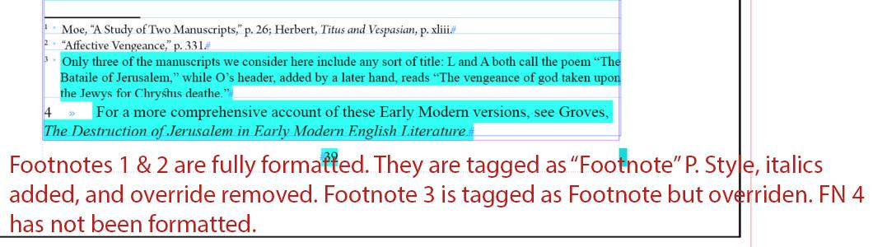

# Headings within the Introduction

Format headings as you encounter them. There are different styles of headings and subheadings, and they require different paragraph styles.

* + - * N.B.: This section does not include changing the standard Header text at the top of the first page or updating the text for any running headers on the Body Pages. These types of headings will be changed in the Final Steps of preparing the edition for print.

## Headings of major sections

See below for an example of what it looks like on import:

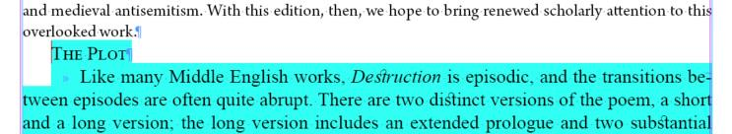

* Make sure there is an **end of paragraph** **symbol** at the end of the heading. If there is a **forced line break** symbol changing the Paragraph Style will alter the paragraph after it.
* Click into the heading and apply Paragraph Style: **Heading**.
  + In the example below, note that there is one end of paragraph symbol at the end of the paragraph before the heading and one end of paragraph symbol at the end of the heading. The correct spacing is built into the Paragraph Style, so don’t add extra end of paragraph symbols around headings.
* The first paragraph after a heading should be styled with **Body First** paragraph style with no indent. Refer to the Formatting Paragraphs section above (p. 4) for guidelines.
  + In the example below, note that there is no tab at the beginning of the first paragraph after a heading; this is the correct format. You may need to remove a tab at the start of the first paragraph of the section to comply with METS Style.

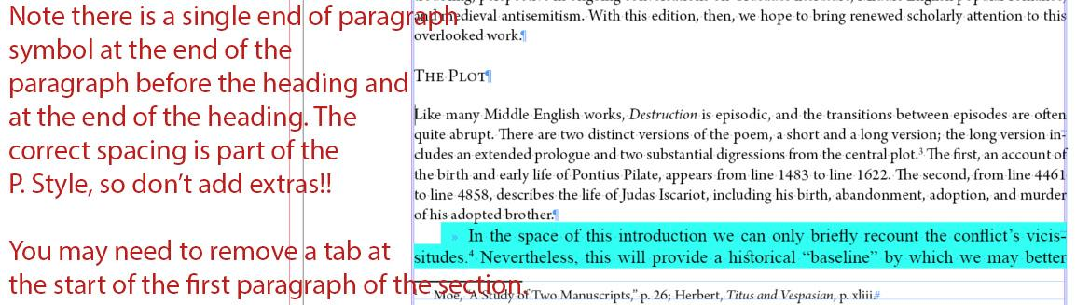

## Second-level headings

See below for an example of what it looks like on import.

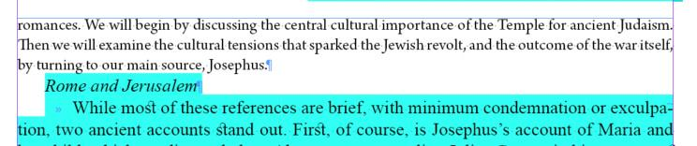

* Make sure there is an **end of paragraph** symbol at the end of the heading. If there is a **forced line break** symbol changing the Paragraph Style will alter the paragraph after it.
* Click into the heading and apply Paragraph Style: **Heading 2**.
  + In the example below, note that there is one end of paragraph symbol at the end of the paragraph before the heading and one end of paragraph symbol at the end of the phrase with Heading 2 applied. The correct spacing is built into the Paragraph Style, so don’t add extra end of paragraph symbols around headings.
* The first paragraph after a second-level heading should be styled as **Body First** paragraph style with no indent. Refer to the Formatting Paragraphs section above (p. 4) for guidelines.
  + In the example below, note that there is no tab at the beginning of the first paragraph after a heading; this is the correct format. You may need to remove a tab at the start of the first paragraph of the section to comply with METS Style.

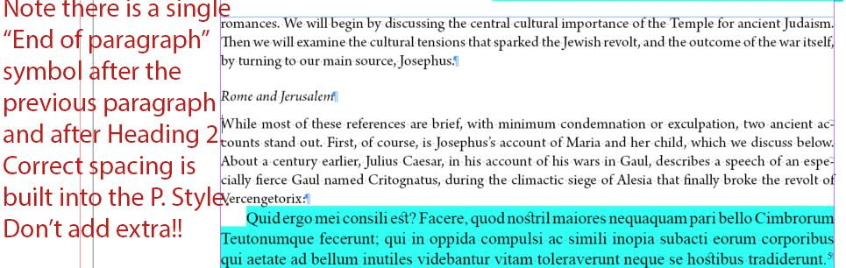

## Headings of smaller subsections

See below for an example of what it looks like on import.

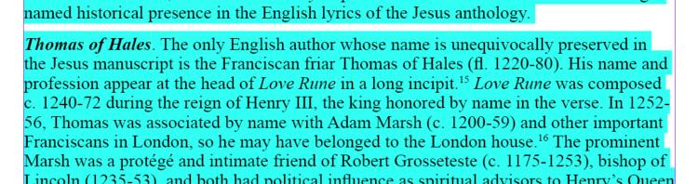

Despite being a heading of a smaller subsection, you need to use a combination of a **Paragraph Style** and **Character Style** for this to work. As with formatting paragraphs, you will want to use the formatting that is present before you clear the override.

* Use the formatting that’s been imported! Refer to the section Character Styles – Formatting Only in the Style Reference for the full list of **Character Styles** to use for formatting. In this example, the “heading phrase” [Thomas of Hale] should be tagged as **Bold Italic**.
* Language tags, only **Arabic** and **Hebrew**, in order to remove overrides (see Style Reference, section Character Styles – Languages, as needed)
* Check **em-dashes** (between clauses) and **en-dashes** (between number ranges) for correctness (see Formatting Reference, sections Em-dash and En-dash, for full instructions)
* Middle English characters (see Formatting Reference, section Middle English Characters)
* Ellipses (see Formatting Reference, section Ellipses)
* Backslash between lines: if there are quoted verse lines within a paragraph separated by a backslash [/], make sure there is a space on either side of the backslash

Apply the Paragraph Style

* Click into the paragraph and re-style the paragraph as **Body Subsection**.
* Clear any overrides. Refer to the Formatting Reference (section Overrides) as needed.
* The first paragraph following this smaller subsection will also receive the paragraph style **Body Subsection**, as all new sections begin with no indentation. This style will also apply the correct amount of white space between the subsection and new section.
* Check against the original text in case all formatting did not import.

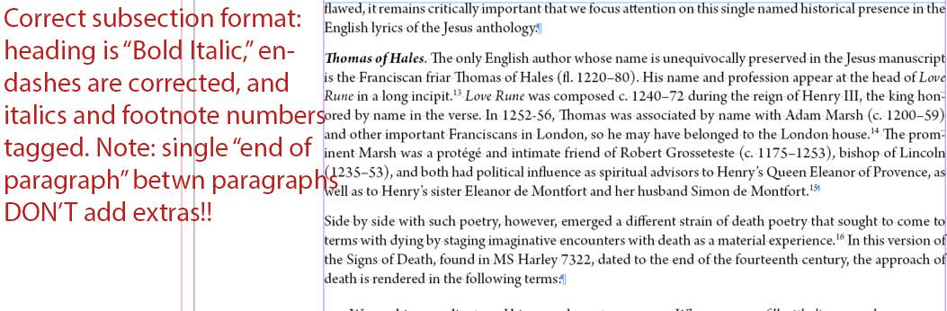

## Headings of lists

If you have a heading to a list (or text that introduces the list but isn’t a larger subsection heading) you need to use **Body Subsection** to apply the correct spacing.

See below for an example of an import of a bulleted list with a heading.

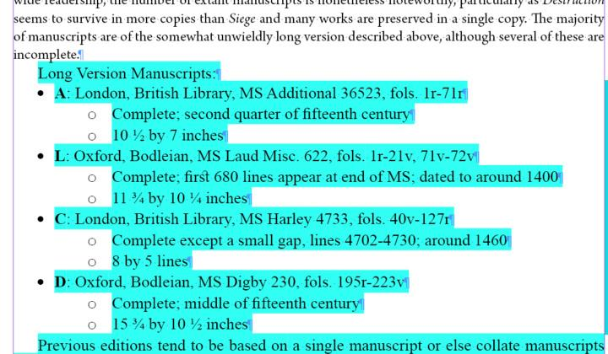

Correct the formatting one line at a time.

* Click into the heading (“Long Version Manuscripts,” in this example) and select **Body Subsection** Paragraph Style. This corrects the font and whitespace of the list heading.

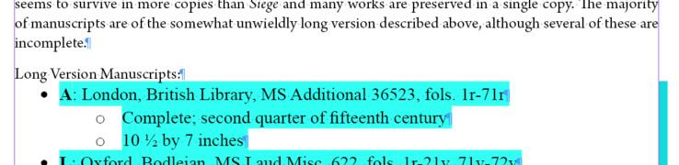

* As when formatting paragraphs, fix the formatting in the line before changing the Paragraph Style or removing overrides.
  + Refer to the section Character Styles – Formatting Only in the Style Reference for the full list of **Character Styles** to use for formatting. If, for instance, the phrase is italic, highlight the entire phrase and then apply the **Italic** Character Style.
  + Language tags, only **Arabic** and **Hebrew**, in order to remove overrides (see Style Reference, section Character Styles – Languages, as needed)
  + Check **em-dashes** (between clauses) and **en-dashes** (between number ranges) for correctness (see Formatting Reference, sections Em-dash and En-dash, for full instructions)
  + Middle English characters (see Formatting Reference, section Middle English Characters)
  + Ellipses (see Formatting Reference, section Ellipses)
  + Backslash between lines: if there are quoted verse lines within a paragraph separated by a backslash [/], make sure there is a space on either side of the backslash

# Quoted Text

Format quoted text as you encounter it. There are different styles of quotations; these require different Paragraph Styles to be formatted correctly.

## Quoted Paragraphs

We use the **Block Quote** Paragraph Style for all prose quotations. These may look like a regular paragraph on import (see below), which is why it is important to have the original document open while formatting.

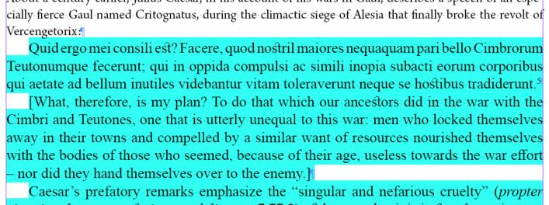

As with formatting paragraphs, you will want to use the formatting that is present before you clear the override.

* Refer to the section Character Styles – Formatting Only in the Style Reference for the full list of **Character Styles** to use for formatting. If, for instance, the phrase is italic, highlight the entire phrase and then apply the **Italic** Character Style.
* Language tags, only **Arabic** and **Hebrew**, in order to remove overrides (see Style Reference, section Character Styles – Languages, as needed)
* Check **em-dashes** (between clauses) and **en-dashes** (between number ranges) for correctness (see Formatting Reference, sections Em-dash and En-dash, for full instructions)
* Middle English characters (see Formatting Reference, section Middle English Characters)
* Ellipses (see Formatting Reference, section Ellipses)
* Backslash between lines: if there are quoted verse lines within a paragraph separated by a backslash [/], make sure there is a space on either side of the backslash

Apply the Paragraph Style

* Click into each Block Quote and tag it as the Paragraph Style **Block Quote**.
  + In the example below, the Block Quote has two paragraphs: one in the original Latin and one in a Modern English translation. Note that the paragraphs with the **Block Quote** paragraph style applied are automatically indented from both margins and that there is a single end of paragraph symbol between each paragraph. All white space is added in through the paragraph styles you apply; don’t add extra manually.
* Clear any overrides. Refer to the Formatting Reference (section Overrides) as needed.
* Check all formatting against the original document.
* Apply **Body Subsection** paragraph style to the paragraph that follows the end of the Block Quote. You may have to delete an extra tab at the beginning of this paragraph to make it conform to METS Style.

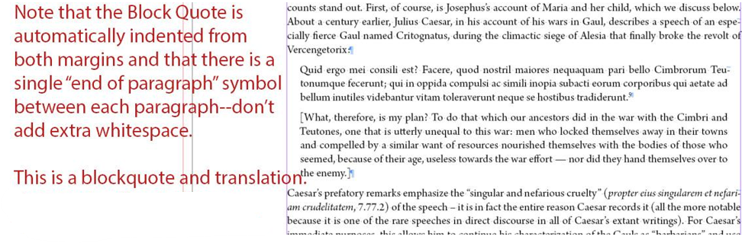

## Quoted Verse Text

We use the **Quoted Line Group** Paragraph Style for all verse quotations; these may include glosses. Typically, when a block quote of verse text is imported, there is an end of paragraph symbol at the end of each line. See example below:

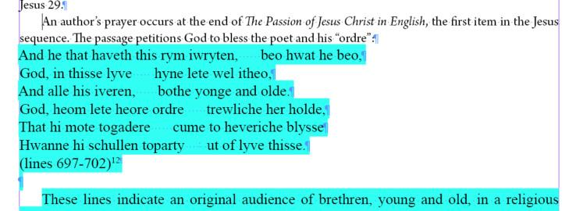

For Quoted Lines, first you must change the “end of paragraph” symbols within each stanza to a “forced line break.”

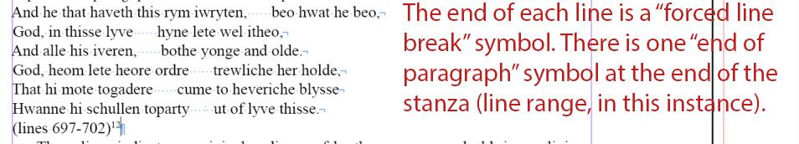

* Manual entry: To change just these “forced line breaks,” use the keyboard shortcut shift+enter at the end of the line, then delete the end of paragraph symbol.
  + Repeat until the only end of paragraph symbols are at the end of the final line of a stanza and at the end of the final line of the quotation itself.
  + If there is citation information on its own line included in the quotation (a line range, in the example above), that line should be considered the final line of the quotation.
* Use the Find / Change function: You can also change end of paragraph symbols to forced line breaks using the Find / Change function (Ctrl+F) **very carefully and one at a time**.
  + Set the Find field to an end of paragraph mark (^p, or click the @ > End of Paragraph).
  + Set the Change field to a forced line break (^n, or click @ > Forced Line Break)
  + Change each symbol one at a time by clicking Find Next, then Change. Do this for the end of each line until you reach the end of the quotation, which should remain an end of paragraph symbol.
  + If there is citation information on its own line included in the quotation, that line should be considered the final line of the quotation.
  + Then, click Done.

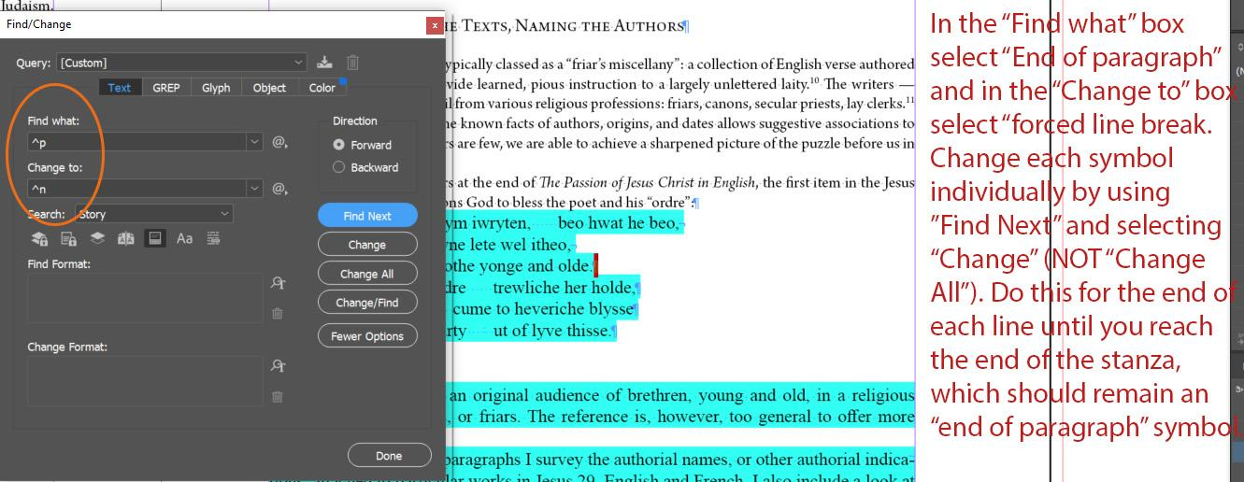

As with formatting paragraphs, you will want to use the formatting that is present before you clear the override. You will not use semantic tags for quotations in the Introduction, even though the quote may be from the volume.

* Refer to the section Character Styles – Formatting Only in the Style Reference for the full list of **Character Styles** to use for formatting. If, for instance, the phrase is italic, highlight the entire phrase and then apply the **Italic** Character Style.
* Language tags, only **Arabic** and **Hebrew**, in order to remove overrides (see Style Reference, section Character Styles – Languages, as needed)
* Check **em-dashes** (between clauses) and **en-dashes** (between number ranges) for correctness (see Formatting Reference, sections Em-dash and En-dash, for full instructions)
* Middle English characters (see Formatting Reference, section Middle English Characters)
* Ellipses (see Formatting Reference, section Ellipses)
* Backslash between lines: if there are quoted verse lines within a paragraph separated by a backslash [/], make sure there is a space on either side of the backslash

### Caesuras in Quoted Verse Text:

Sometimes lines in quoted verse text include caesuras: a purposeful break between two parts of a line. We include 6 spaces for each caesura; all six spaces need to be tagged with the **Caesura** Character Style in these quotes, as well as in the text.

* For full instructions, see the Formatting Reference (section Caesura)

Example of Quoted Line Group with Caesuras:

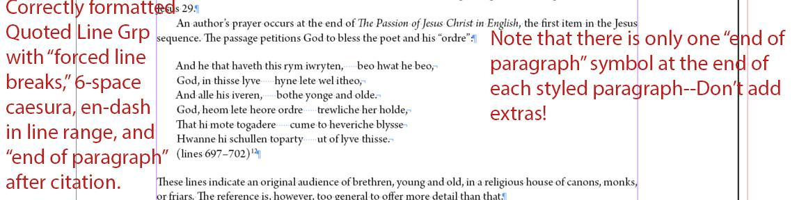

### Glosses included in Quoted Verse Text:

* After you have completed the above instructions for Block Quotes: Verse Text, highlight the entire glossed phrase and apply the **Italic** Character Style.
  + Don’t use Gloss Character Style; we only use the Gloss Character Style in Text files, not in the apparatus

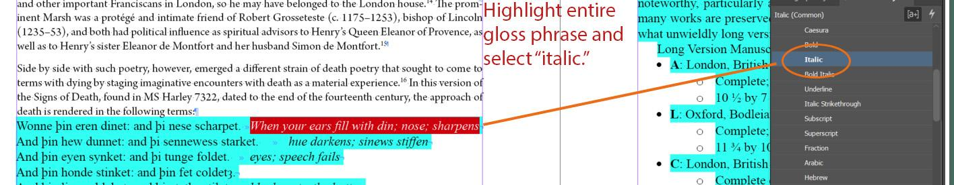

Finally, fix the Paragraph Style overrides

* Click into each stanza of the quoted verse text and tag it as the Paragraph Style **Quoted Line Group**.
* Clear any overrides. Refer to Formatting Reference (section Overrides) as needed.
* Check all formatting against the original document.
* Apply **Body Subsection** paragraph style to the paragraph that follows the end of the Block Quote. You may have to delete an extra tab at the beginning of this paragraph to make it conform to METS Style.

Example of Quoted Line Group with Glosses:

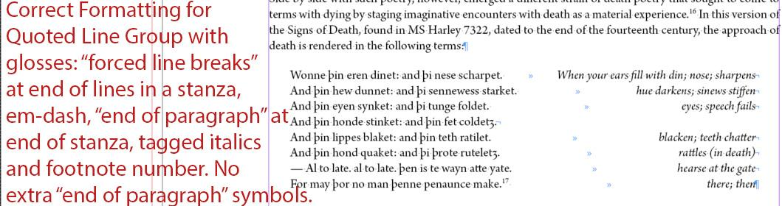

## Quoted Verse Text in Columns

Use **Quoted Line Group Columns** Paragraph Style when a quote in its original language has a translation provided for the entire excerpt. We also apply this for comparisons between two witnesses.

* First, make sure the original language and the translation are in one stanza, with forced line breaks at the end of each line. **Do not try to make columns using tabs.** Have the original language first, followed by the translation.
  + Ex.

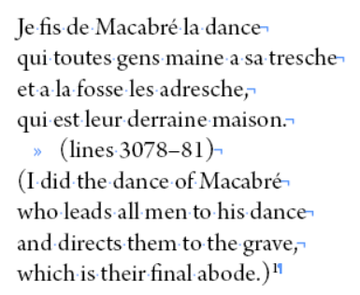

* Apply **Quoted Line Group Columns** Paragraph Style
* Add a column break at the end of the original language:
  + Right Click > Insert Break Character > Column Break.

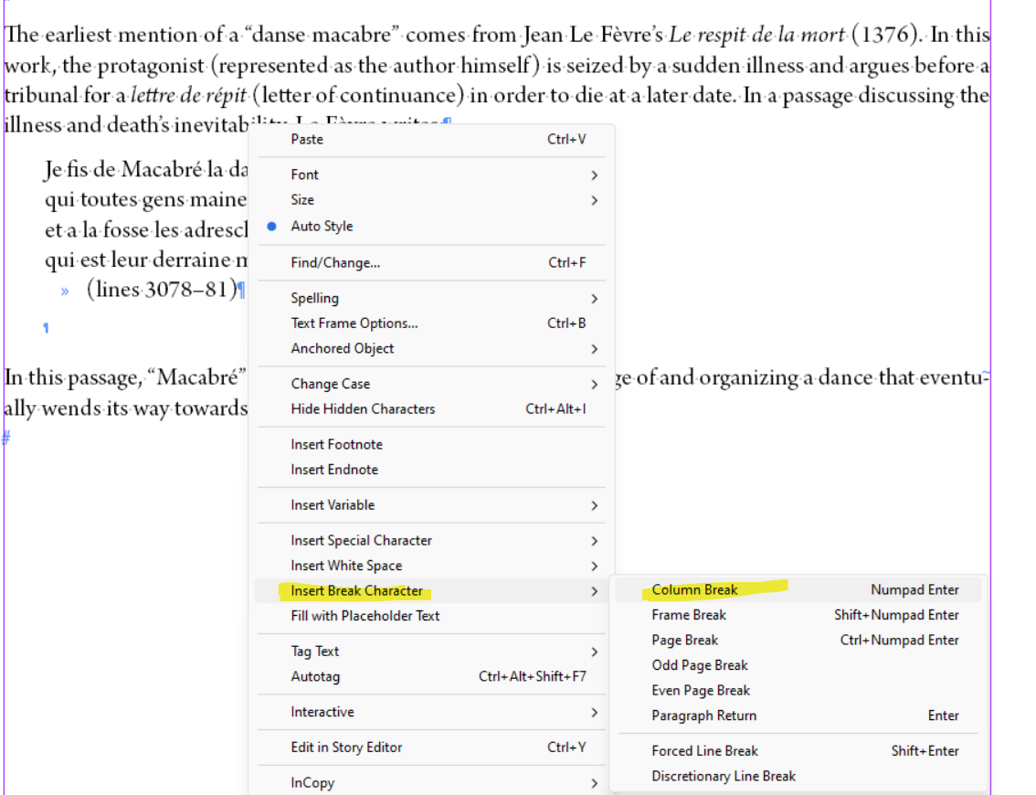

* Check the column alignment; you may need to delete an extra forced line break to ensure the lines align correctly.

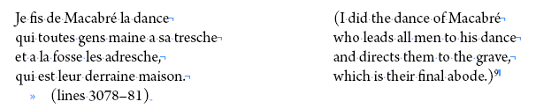

Finally, fix the Paragraph Style overrides

* Clear any overrides. Refer to Formatting Reference (section Overrides) as needed.
* Check all formatting against the original document.
* Apply **Body Subsection** to the paragraph that follows the end of the Quoted Verse Text in Columns.

Note in the oXygen Interventions spreadsheet, Sheet 3: Additional Changes to TEI, if there are any block quotes with columns. Note their location and if there are stanzas in the columns.

## Quoted Textual Note

If textual notes from the edition are quoted in an introduction, apply the **Quoted Textual Note** Paragraph Style.

* As when formatting paragraphs, fix the formatting in the line before changing the Paragraph Style or removing overrides.
* Make sure the location of the note is clarified (Line 140), followed by a single tab and then the contents of the note.

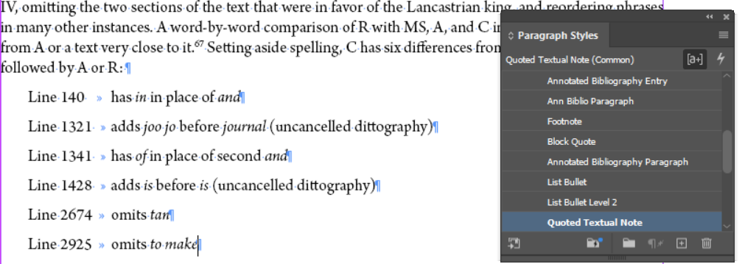

Finally, fix the Paragraph Style overrides

* Click into each Quoted Textual Note and make sure it is tagged as the Paragraph Style **Quoted Textual Note**.
* Clear any overrides. Refer to Formatting Reference (section Overrides) as needed.
* Check all formatting against the original document.
* Apply **Body Subsection** to the paragraph that follows the end of the Quoted Textual Note.

# Lists

First, check for a heading or text that introduces the list but isn’t a larger subsection heading. If one is present, follow the above instructions for Headings of lists. Then, correct the formatting for each list type one line at a time.

## Bulleted Lists

See below for an example of an import of a bulleted list with a heading.



* As when formatting paragraphs, fix the formatting in the line before changing the Paragraph Style or removing overrides.
  + Refer to the section Character Styles – Formatting Only in the Style Reference for the full list of **Character Styles** to use for formatting. If, for instance, the phrase is italic, highlight the entire phrase and then apply the **Italic** Character Style.
  + Language tags, only **Arabic** and **Hebrew**, in order to remove overrides (see Style Reference, section Character Styles – Languages, as needed)
  + Check **em-dashes** (between clauses) and **en-dashes** (between number ranges) for correctness (see Formatting Reference, sections Em-dash and En-dash, for full instructions)
  + Middle English characters (see Formatting Reference, section Middle English Characters)
  + Ellipses (see Formatting Reference, section Ellipses)
  + Fractions (see Formatting Reference, section Fractions)
  + Backslash between lines: if there are quoted verse lines within a paragraph separated by a backslash [/], make sure there is a space on either side of the backslash
* Then click into the first bulleted line and select Paragraph Style **List Bullet** and clear the override. Each bullet point should be followed by an end of paragraph symbol.
  + Repeat this for each line of the bulleted list.

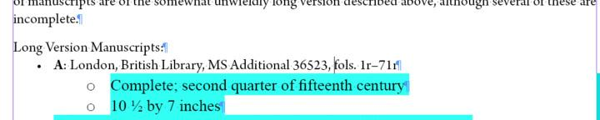

* For bulleted lists that have items at a second-level hierarchy (aka the lines with the hollow white bullet that are further indented in the example), follow the same steps as above but choose the Paragraph Style **List Bullet Level 2** before clearing the override.

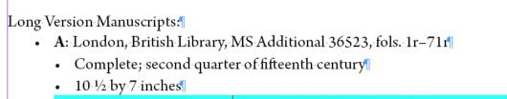

* Apply **Body Subsection** to the paragraph that follows the end of the bulleted list.

Example of correctly formatted bulleted list:

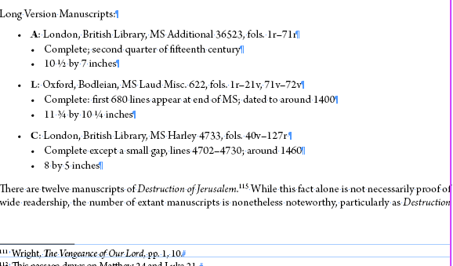

## Lists with No Bullets

Sometimes, we need a list but do not require a visible bullet for each item in the list. This often occurs in lists of manuscripts.

* As when formatting paragraphs, fix the formatting in the line before changing the Paragraph Style or removing overrides.
* Each item of the unbulleted list should have an end of paragraph symbol after it and receive the Paragraph Style **List No Bullet**.

Example of correctly formatted non-bulleted list:

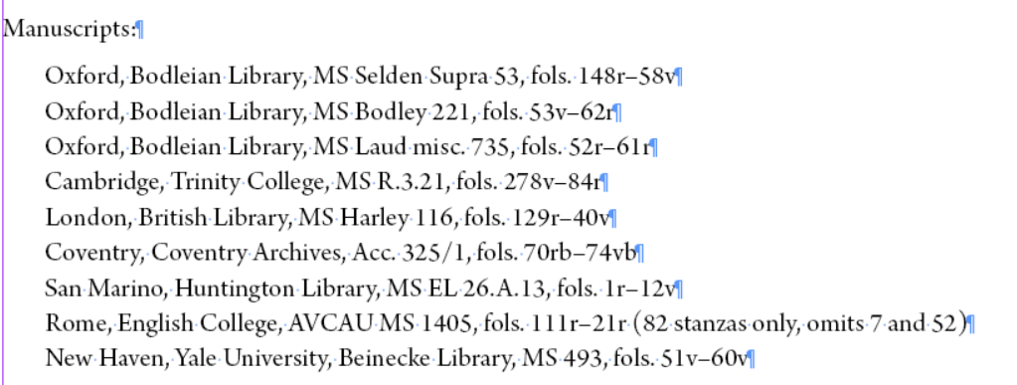

* For non-bulleted lists that have items at a second-level hierarchy and therefore need to be further indented, follow the same steps as above but choose the Paragraph Style **List No Bullet Level 2** before clearing the override.
  + N.B.: It is important that we accurately represent the levels of the list in their formatting. This is why we use a Level 2 paragraph style and not a tab to indent the text further over.
* Apply **Body Subsection** to the paragraph that follows the end of the non-bulleted list.

## Numbered Lists

Numbered lists generate numbers automatically for each item in the list and function much like bulleted lists.

* As when formatting paragraphs, fix the formatting in the line before changing the Paragraph Style or removing overrides.
* Each item of the numbered list should have an end of paragraph symbol after it and receive the Paragraph Style **List Numbers.**
  + After applying the paragraph style, double check to see that each item is numbered, and that there is only one number for each item. Sometimes applying the **List Numbers** paragraph style causes there to be two sets of numbers for each item: one set from the original list, and one set automatically applied by the paragraph style. If this has happened, delete the set from the original list, not the set applied by the paragraph style.
  + If there are multiple lists close to each other, keep an eye on the numbering. InDesign sometimes makes the numbering continuous across lists. Double check whether the numbering should be continuous. If it is not supposed to be continuous, but InDesign has made it so, make this a query and check in with the Managing Editor on how to proceed.

Example of correctly formatted numbered list:

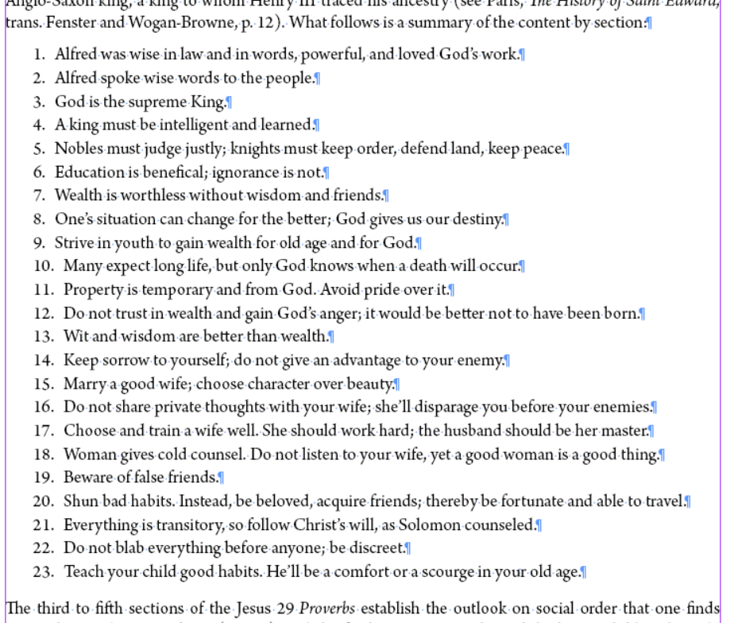

* If this is not the first Numbered List or Lettered List that has been added to the document, then the first item will not start with 1 or a. Instead, it will pick up numbering / lettering from the previous list. You will need to manually reset this in InDesign.
  + Click into the first line of the new list.
  + Then click Type > Bulleted and Numbered Lists > Restart Numbering.
  + This will reset the ordering in the list, regardless of whether it is a List Numbers or List Letters paragraph style that has been applied.
  + N.B.: This will create an override in the text. Clearing this override will reset the numbering to continuous numbering, which will be incorrect for print. Leave this override in the text.
* Apply **Body Subsection** to the paragraph that follows the end of the numbered list.

## Lettered Lists

Lettered lists generate letters automatically for each item in the list and function much like bulleted lists.

* As when formatting paragraphs, fix the formatting in the line before changing the Paragraph Style or removing overrides.
* Each item of the numbered list should have an end of paragraph symbol after it and receive the Paragraph Style **List Letters.**
  + After applying the paragraph style, double check to see that each item is lettered, and that there is only one letter for each item. Sometimes applying the **List Letters** paragraph style causes there to be two sets of letters for each item: one set from the original list, and one set automatically applied by the paragraph style. If this has happened, delete the set from the original list, not the set applied by the paragraph style.

Example of correctly formatted lettered list:

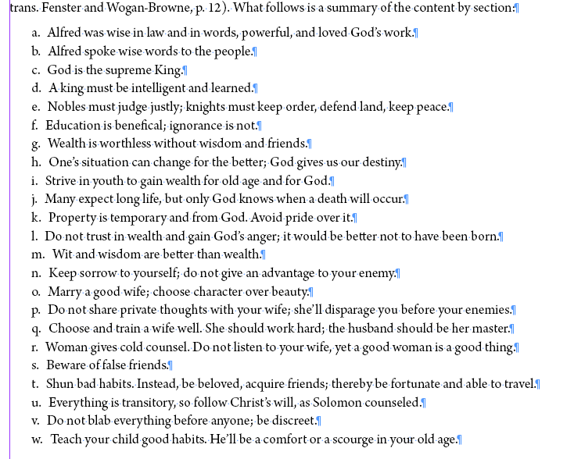

* If this is not the first Numbered List or Lettered List that has been added to the document, then the first item will not start with 1 or a. Instead, it will pick up numbering / lettering from the previous list. You will need to manually reset this in InDesign.
  + Click into the first line of the new list.
  + Then click Type > Bulleted and Numbered Lists > Restart Numbering.
  + This will reset the ordering in the list, regardless of whether it is a List Numbers or List Letters paragraph style that has been applied.
  + N.B.: This will create an override in the text. Clearing this override will reset the numbering to continuous numbering, which will be incorrect for print. Leave this override in the text.
* Apply **Body Subsection** to the paragraph that follows the end of the lettered list.

# Bibliography Entries

Occasionally introductions will contain bibliography entries, which sometimes have annotations associated with them.

This is distinct from a list of Witnesses, Manuscripts and/or Editions, or a Further Reading list. If you encounter either of those lists, look back to the original Word document for what formatting to apply and refer to the appropriate section in this workflow.

See below for a sample of what a bibliography entry with annotation looks like on import

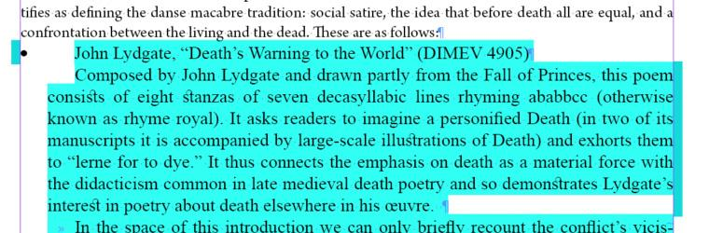

* In the bibliography entry (John Lydgate, “Death’s Warning”) and the following annotation, add in any formatted needed, as you would with a paragraph:
  + Refer to the section Character Styles – Formatting Only in the Style Reference for the full list of **Character Styles** to use for formatting. If, for instance, the phrase is italic, highlight the entire phrase and then apply the **Italic** Character Style.
  + Language tags, only **Arabic** and **Hebrew**, in order to remove overrides (see Style Reference, section Character Styles – Languages, as needed)
  + Check **em-dashes** (between clauses) and **en-dashes** (between number ranges) for correctness (see Formatting Reference, sections Em-dash and En-dash, for full instructions)
  + Middle English characters (see Formatting Reference, section Middle English Characters)
  + Ellipses (see Formatting Reference, section Ellipses)
  + Backslash between lines: if there are quoted verse lines within a paragraph separated by a backslash [/], make sure there is a space on either side of the backslash
* Click into the bibliography entry and apply the **List Bullet** Paragraph Style

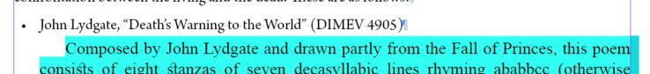

* Then, click into the annotation and apply the **Annotated Bibliography Paragraph** Paragraph Style

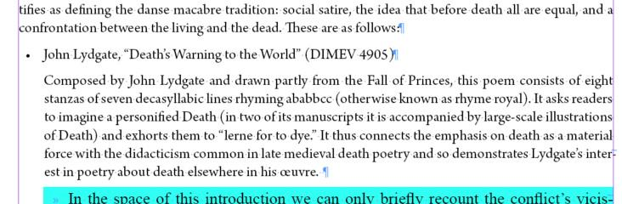

* Repeat as needed for all bibliography entries and their annotations.
* Note that there are no extra “end of paragraph” symbols added in to create whitespace; the correct whitespace is created by the paragraph styles we apply.

See the example below for what a typical two-page spread in an in-progress introduction may look like.

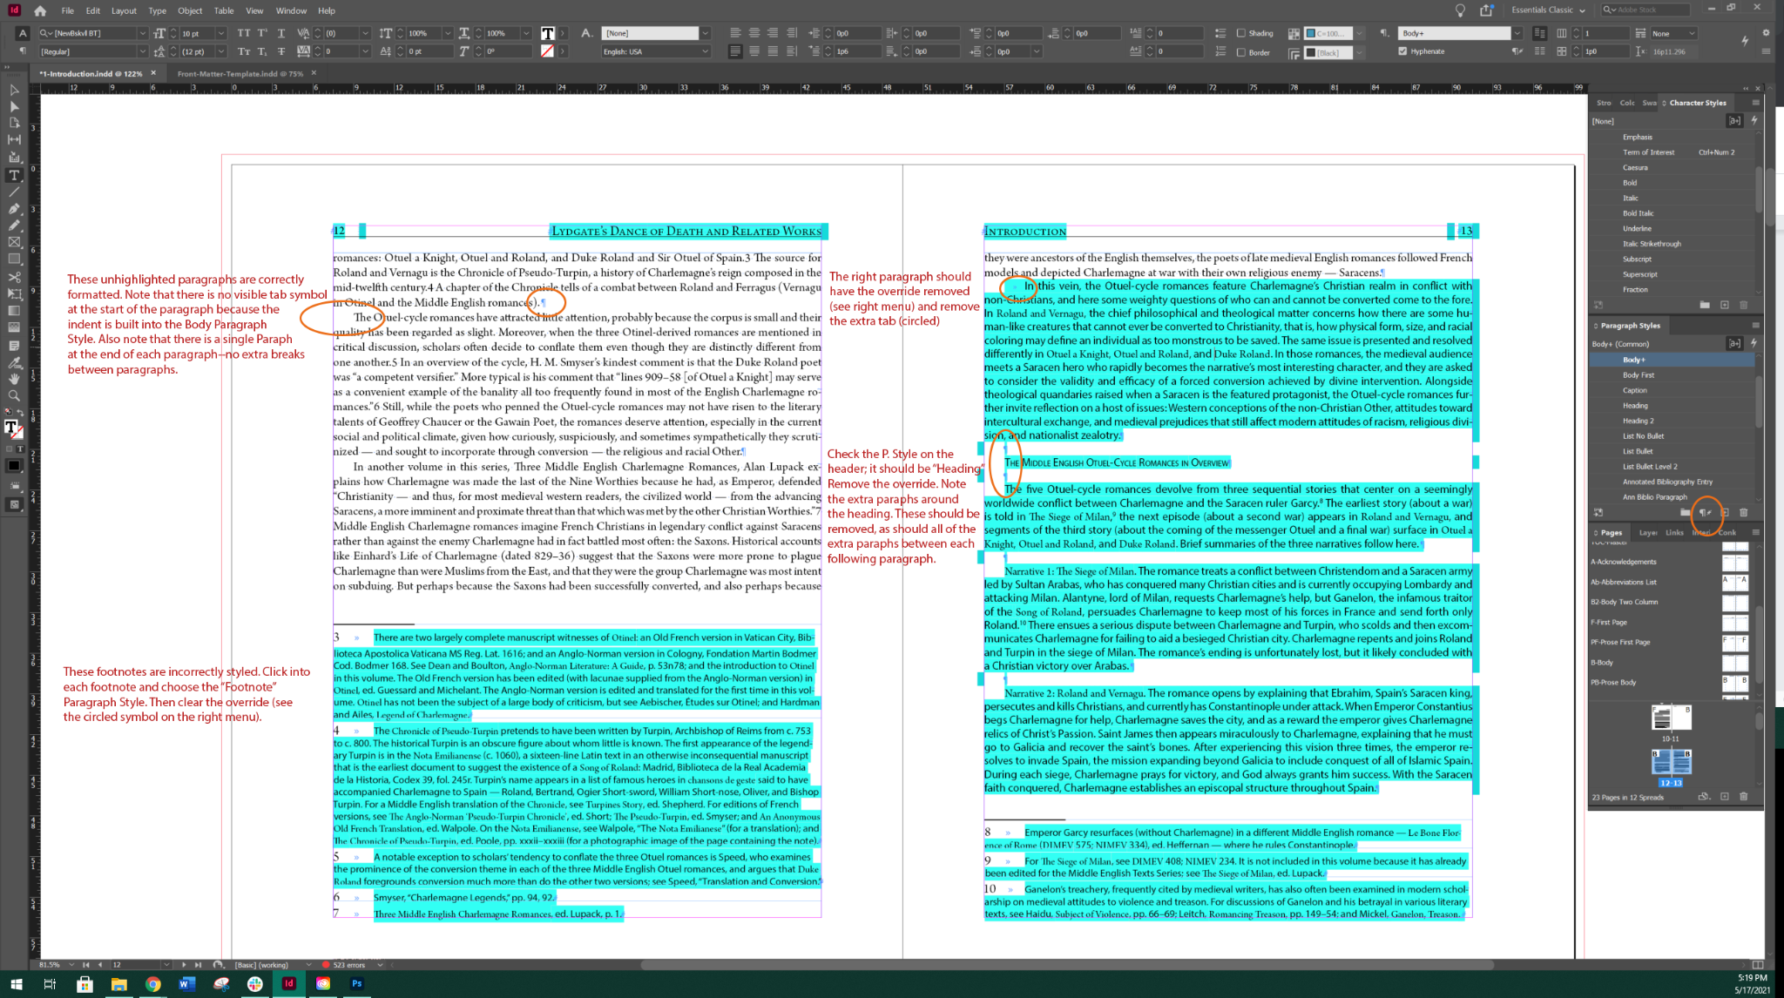

* The unhighlighted paragraphs on the verso page are correctly formatted. Note that there is no visible tab symbol at the start of the paragraph because the indent is built into the Body Paragraph Style. Also note that there is a single end of paragraph symbol at the end of each paragraph, with no extra break characters between paragraphs.
* The footnotes are incorrectly styled. In order to fix them, click into each footnote and choose the Footnote paragraph Style, Then, clear the override.
* On the recto page, the first paragraph should have the override removed and the initial tab deleted.
* On the recto page, check the paragraph style applied to the heading “The Middle English Otuel-Cycle Romances in Overview.” The correct paragraph style should be Heading. Then, remove the override. Note the extra end of paragraph symbols around the heading. These should be removed, as should all of the extra end of paragraph symbols between each of the following paragraphs.

# Final Pagination Adjustment before Moving on to the next Document

First, make sure that the hashtag that indicates the end of the text appears after the final punctuation on the page. Pagination should be more or less set before you move onto a new document. Refer to the Formatting Reference for more information about setting pagination once your document is complete. See the Completing a Text Frame section and the Document Pagination section of the Formatting Reference for more details.